SURNAME: FIRST NAME: ORGANISATION:
Address:

E mail:
Phone: Fax:

TYPE OF PAPER Poster – Oral presentation

THEME OF PAPER: (Copy and paste one or several themes from the “words cloud” below and then erase the picture)
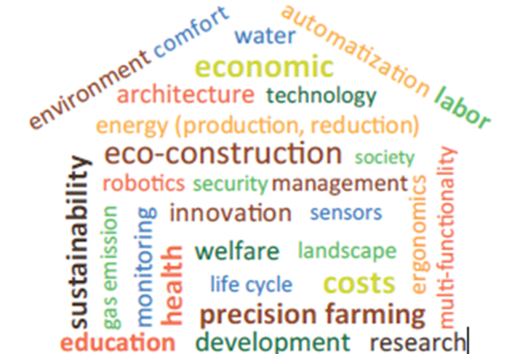

PAPER TITLE:

If the work has already been published please specify in which journal and in which language:

AUTHOR 1 AND AFFILIATION:
AUTHOR 2 AND AFFILIATION:
AUTHOR 3 AND AFFILIATION:

SUBMISSION SUMMARY (Establish the subject, objectives of the work, theoretical basis, main results and applications. For posters: detailed plan):

(Please maximum 400 words)

European forum - Lille 2017 – Instructions for authors

European forum - « Livestock housing: let’s build the future » - Lille (France)
from 2017/02/22 (2:00 p.m.) to 2017/02/24 (1:00 p.m.)
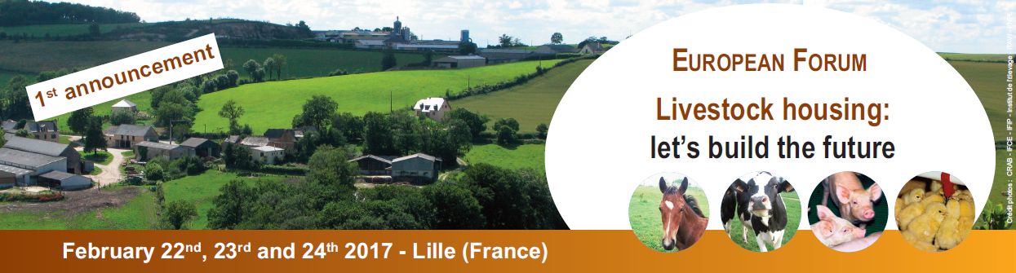

Instructions for authors :
Themes and topics: papers and/or posters should be related to animal housing conditions for the future, including housing systems and equipment and should address at least one of the themes and topics presented in the first announcement flyer or in the “communication chart” file.
Communications goal: a presentation of scientific/technical research programs and/or results, linked to proposed themes in the field of animal housing improvement for the future. A special attention should be paid to the possibilities of easy application for methods and proposed solutions.
Languages: French / English.
Proposals can be written either in French or in English (summaries, and then slideshows or posters). A translation will be provided by the organizers of this forum (translation of all the summaries and oral presentations or posters before the venue AND simultaneous translation for oral presentations during plenary sessions).
Types of communication: two possibilities are available
- Oral presentation: 15 to 20’ (+ time for questions / answers), during plenary sessions or smaller workshops : a PowerPoint slideshow following a template, proposed by the organizers
- or Poster (posters will be presented during the whole congress and a special sequence to allow further exchanges with the authors will be organized), A0 format = 119 x 84, or A1 format = 84 x 60, (a template will be provided later)
NB : All the oral presentations or posters should be submitted the same way (summary following the communication chart).
Scheduling: same three steps, for any type of presentation (oral or poster)
- 2016/08/26 : summary in 400 words (title and qualities of the authors not included), following this template « International forum-Lille-2017_instructions for authors.docx »
- 2016/10/10: selection of the communication by the forum committee.
Four different types of responses are possible:
- Abstract accepted for an oral presentation (plenary session or workshop) + possible additional remarks from the committee
- Abstract accepted on a second level list for an oral presentation (plenary session or workshop) + possible additional remarks from the committee. A final decision might be taken later
- Abstract accepted for a poster presentation + possible additional remarks from the committee
- Abstract rejected
- Final transmission of the presentation
- 2017/01/20 : PowerPoint slideshow files for plenary sessions or workshops
- 2017/02/13 : PDF files for the posters
- At you arrival : posters deposit to the welcome board + files checking (compatibility) for both oral presentations and posters

